Jennifer

Observations and Playtester Comments

# In-Game Observations

[Your thoughts as you watch the testers play]

* Backstory slide looks good
* Still need more conversations at this point, so not much gameplay

# In-Game Questions

Why did you make that choice?

* I decided to go into the houses because there was an entrance there and I did not know what else to do

Does that rule seem confusing?

* There were no rules except for moving around and interacting

What did you think that would do?

* I thought going into a house would give me more people to interact with

What is confusing for you?

* No end objective

# Postgame Questions

[Questions you ask the testers as they have played]

* Could there be anything else in the game that you would like to see? Maybe a battle or something?
  + I think adding a battle aspect would not give it that much good gameplay because I think this is more of an explorer game rather than a battle game
* Did you like exploring it or would you want to explore it with friends?
  + I think exploring it by myself would be better

## General Questions

What was your ﬁrst impression?

* Everything was very cute, in a very cartoony, satisfying style

How did that impression change as you played?

* Everything had the same animations and style so it did not change

Was there anything you found frustrating?

* No end objective

Did the game drag at any point?

* no

Were there particular aspects that you found satisfying?

* The controls were easy to understand

What was the most exciting moment in the game?

* Interacting with the bunny

Did the game feel too long, too short, or just about right?

* Too short

## Formal Elements

Describe the objective of the game.

* No backstory so do not know entirely

Was the objective clear at all times?

* no

What types of choices did you make during the game?

* What house to go into, who to interact with

What was the most important decision you made?

* They all were weighted the same

What was your strategy for winning?

* No way to win

Did you ﬁnd any loopholes in the system?

* There was a bug next to two people at once, you skipped over one conversation

How would you describe the conﬂict?

* Not quite sure

In what way did you interact with other players?

* There were no other players

Do you prefer to play alone or with human opponents?

* I actually like playing against other people

What elements do you think could be improved?

* Perhaps something to show where to move around the town since it is very zoomed in

## Dramatic Elements

Was the game’s premise appealing to you?

* As far as I know, yes. I love explorer games

Did the story enhance or detract from the game?

* The conversations added to the game

As you played, did the story evolve with the game?

* As I got to know more people, it did evolve

Is this game appropriate for the target audience?

* yes

On a piece of paper, graph your emotional involvement over the course of the game.

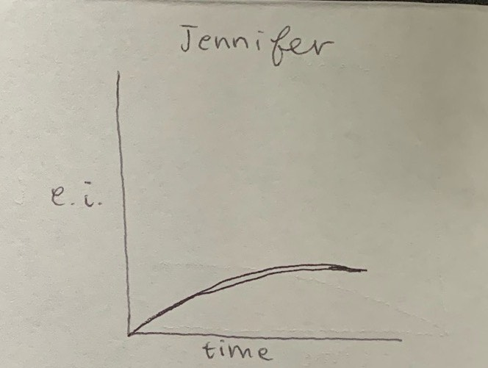

Did you feel a sense of dramatic climax as the game progressed?

* no

How would you make the story and game work better as a whole?

* It was pretty good, just add backstory to let me know what happened

## Procedures, rules, interface, and controls

Were the procedures and rules easy to understand?

* yes

How did the controls feel? Did they make sense?

* They made sense, just use keyboard arrows

Could you ﬁnd the information you needed on the interface?

* yes

Was there anything about the interface you would change?

* no

Did anything feel clunky, awkward, or confusing?

* no

Are there any controls or interface features you would like to see added?

* no

## End of Session

Overall, how would you describe this game’s appeal?

* A one player explorer game, appealing for children

Would you purchase this game?

* no

What was missing from the game?

* An objective really

If you could change just one thing, what would it be?

* Add a backstory

Who do you think is the target audience for this game?

* kids

If you were to give this game as a gift, who would you give it to?

* My nephew

# Revision Ideas

[Ideas you have for improving the game]

* Long enough for game play now
* Still need to have updates for empathy bar